Monitoring an EC2 instance with custom metrics

Step 1: Login to your AWS lab Click on Services, and under Security, Identity, & Compliance, select IAM
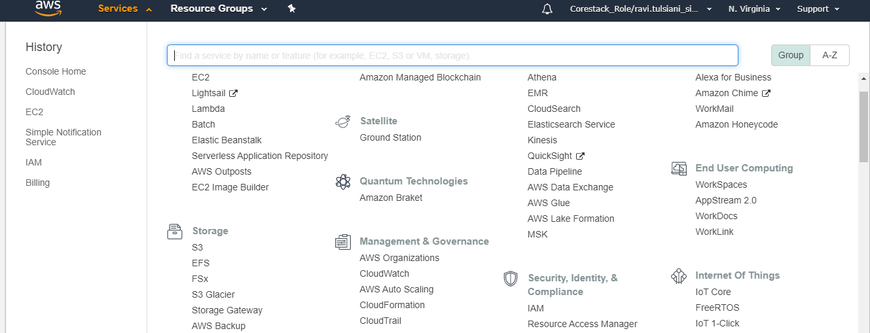

Step 2: In the navigation pane, select Roles and click on Create role

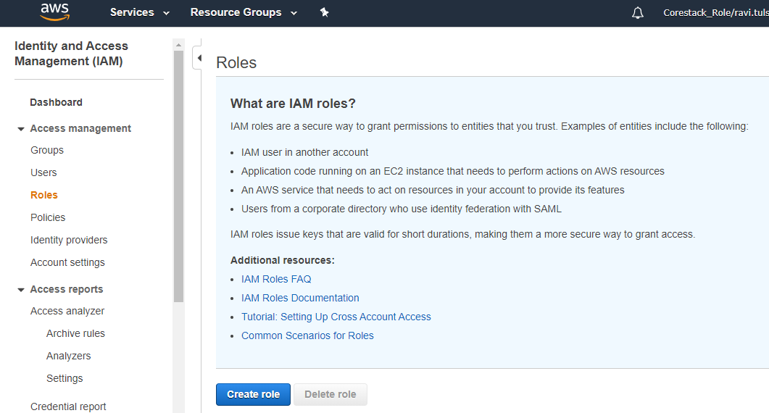

Step 3: Click on EC2 and then click on Next: Permissions
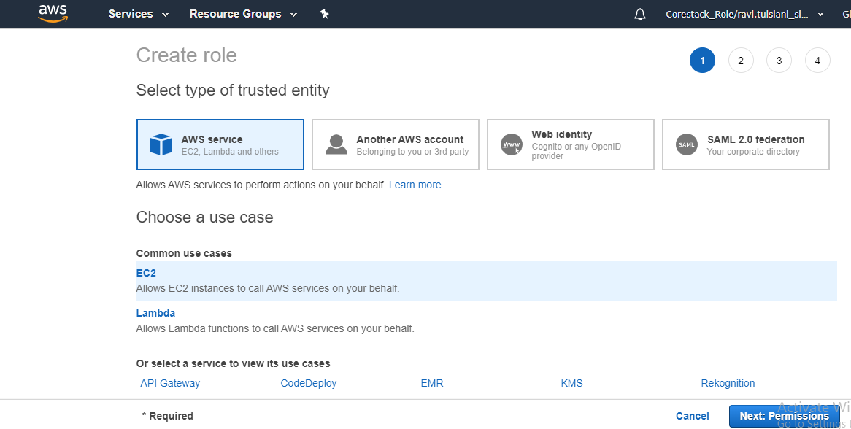
Step 4: Select the CloudWatchFullAccess policy
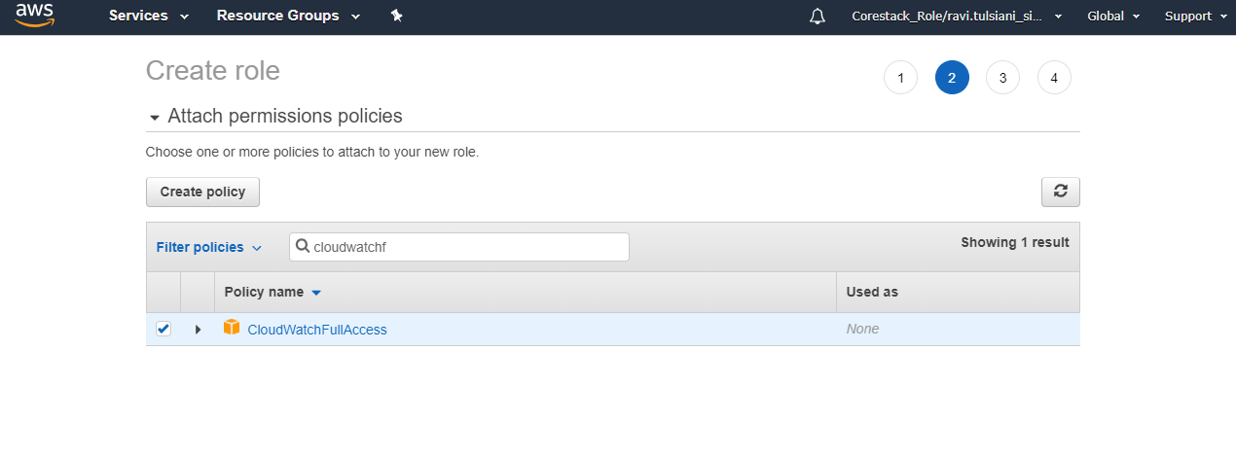
Step5:Provide the role name and click on Create role
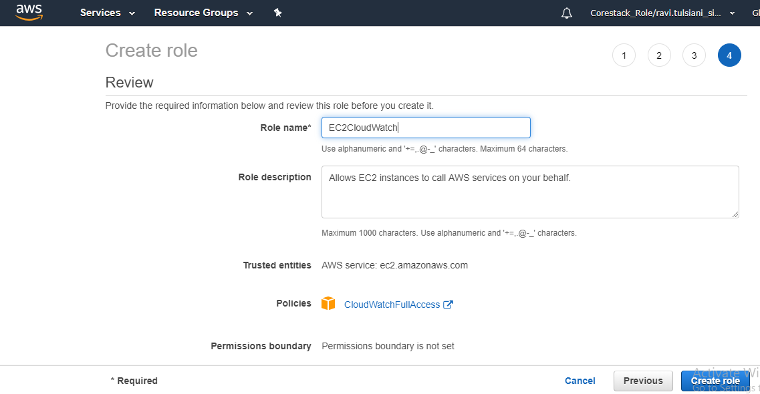

Step 6:Go to Services -> EC2
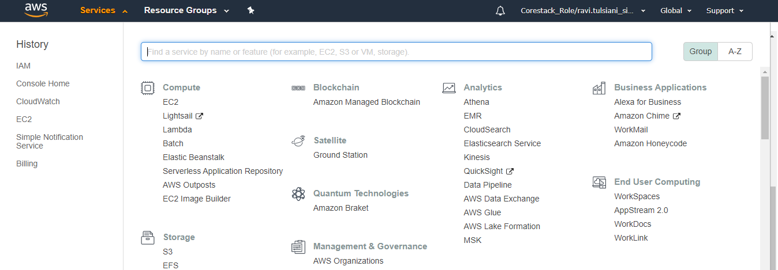
Step 7: Create a new EC2 instance per your requirements.In step 3 of configure instance details select the created IAM role and copy the following script in the Advanced Details textbox:
#!/bin/bash
yum update -y
sudo yum install -y perl-Switch perl-DateTime perl-Sys-Syslog perl-LWP-Protocol-https perl-Digest-SHA.x86_64
cd /home/ec2-user/
curl https://aws-cloudwatch.s3.amazonaws.com/downloads/CloudWatchMonitoringScripts-1.2.2.zip -O
unzip CloudWatchMonitoringScripts-1.2.2.zip
rm -rf CloudWatchMonitoringScripts-1.2.2.zip
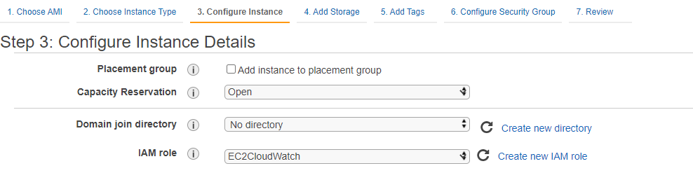
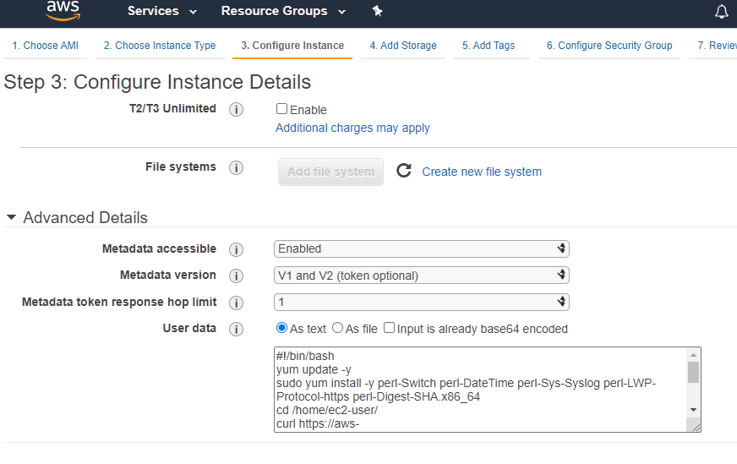
Step 8:Add a tag to the instance
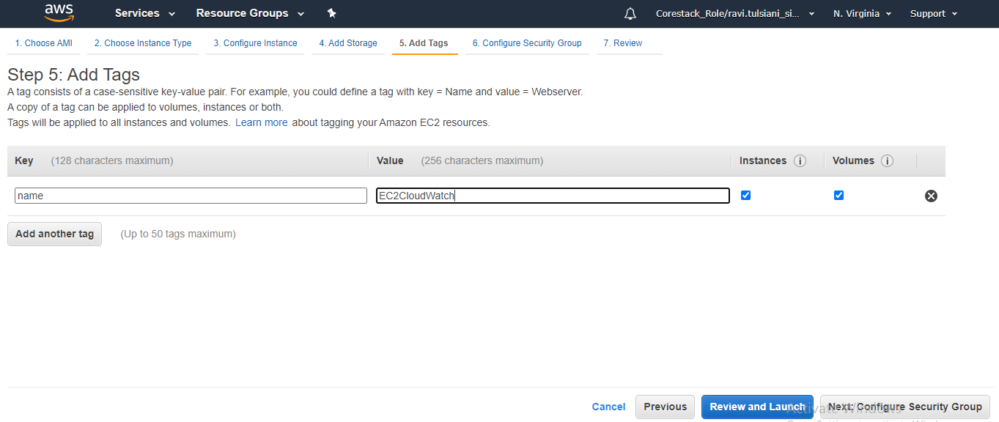
Step 9: Click on Review and Launch
Step 10: Create a new key-value pair, download it, and click on Launch instances
Step 11: Using PuTTY, login to the session. Type sudo su to the terminal to enter into the admin role
Step 12: In the AWS console, go to CloudWatch
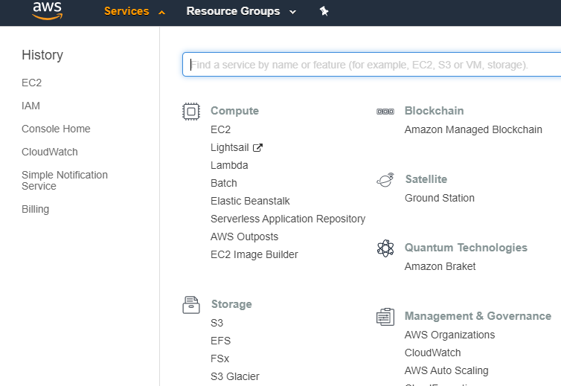
Step 13: Select EC2. We can see that there are no other metrics in CloudWatch
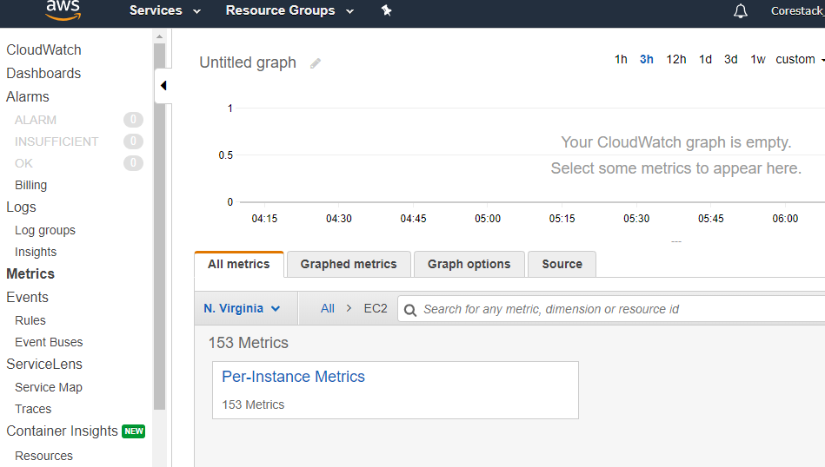
In the terminal, type the following command:
/home/ec2-user/aws-scripts-mon/mon-put-instance-data.pl --mem-util --verify --verbose

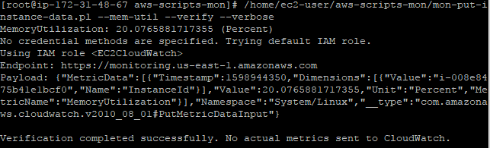

Step 14: Type the following command in the terminal:
/home/ec2-user/aws-scripts-mon/mon-put-instance-data.pl --mem-util --mem-used --mem-avail
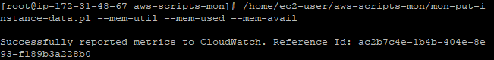
Step 15: Go to CloudWatch again, refresh the page, and see a new metric added to the CloudWatch
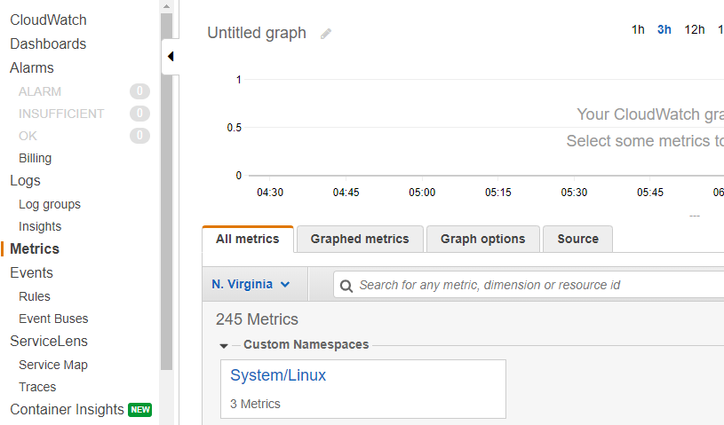

Click on the newly created metric, and we can see the memory metric
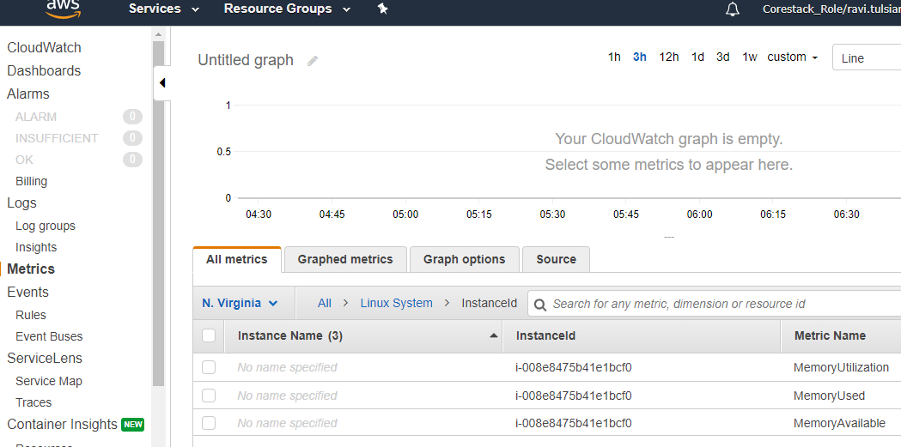
Step 16: Go back to the terminal and type the following commands:
cd /etc
nano crontab
*/1 * * * * root /home/ec2-user/aws-scripts-mon/mon-put-instance-data.pl --mem-util --mem-used --mem-avail
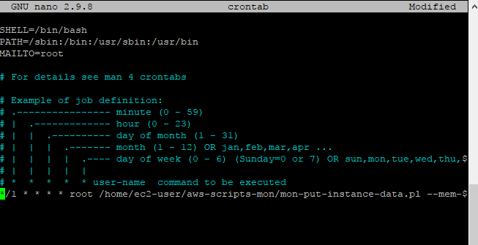
Go to AWS Console -> CloudWatch -> Metrics to see the status of the metrics
